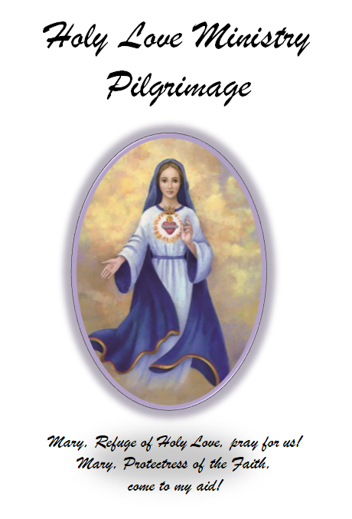

+++ for this ISLAND OF GRACE +++

Summary of Messages for Pilgrims
to Holy Love Ministry/Maranatha Springs
in Elyria Ohio

In Advance
- should prepare in advance with prayer and sacrifice so that their hearts are ready to receive the graces that are offered here."
- accept any inconvenience that this journey presents. I speak not only of the journey here to this site, but the journey through the Chambers of Our United Hearts, as well
- do not anticipate any certain grace
Right Before You Go Onto the Property
- pray the pilgrimage prayer
- Make a sincere heartfelt Act of Contrition before you come onto the property. Grace will then fill your heart
- Please ask the people to ask Jesus to forgive them any lack of love in their hearts as they approach the Spring and Lake of Tears."
Attitude
- He anticipates much, but believes that whatever God gives is exactly what God wants him to have and is from God.
- The sincere heart does not step onto the property seeking to disprove all that is offered here; nor does he seek proof from Heaven that all the graces offered here are genuine.

- The one with a sincere heart is like a blank page waiting for the Hand of God to write on it; or it is like a fisherman who casts his empty net into the sea and waits eagerly for God to fill it. He anticipates much, but believes that whatever God gives is exactly what God wants him to have and is from God."
Once On Property
- heart of each pilgrim be open
- Those who recite the stations will find solace and healing
- when your hearts are prepared as I desire, you will be given the truth as to your state before God
- It is here I invite every soul into the New Jerusalem, which is your personal sanctification in and through Holy Love.
- The greatest miracle given at this site is the grace to live in Holy Love in the present moment. Appreciate this; ask for it when you come here and it will be granted. You are given special angels to assist you
- Those of My children who step onto the property with sincere hearts; that is, a heart open to belief - not searching of reasons to disbelieve - will be plunged into the First Chamber of My Immaculate Heart and Its Purifying Flame, as they receive the Seal of Discernment that My Son will place upon their foreheads
- At the property or through the use of the water at the many sources there present, the pilgrim will receive the illumination of conscience.
- "Heaven makes use of individual senses: sight, sound, scent, even touch to proclaim its Presence here; but it is only the sincere of heart who receive the Seal of Discernment."
- Once you step onto the property,** if you are in touch with the Holy Spirit, you will know with certainty this Mission is genuine.
Impact
- It is here you can feel the depth of My Love for you and the compassion of My Mother's Heart."
- here you will be united in the Truth - the Truth which is Holy Love
After you leave
- Do not look for proof of all that takes place here as being from Heaven. Do not come here to find fault
- When you share your experiences, do so giving God the glory, for all grace comes from His Mercy and His Love
- I desire that each pilgrim returns the embrace to Our United Hearts by living the Message of Holy and Divine Love in their own hearts

"Grace abounds here. The message is the only message he need hear, because it envelops every message.

Source: www.holylove.org
Reproduced by Topic and summarized on: www.protectressofthefaith.org/index.php/pilgrimage-information/pilgrimages/

Pilgrimage-Summary-of-Messages-v2.2 10.04.2017
(messages as of 09.25.2016)

Prayer to be recited by Visiting Pilgrims
“I am your Jesus, born Incarnate. Here, child, is a prayer I desire all who journey in pilgrimage to the prayer site, recite:”

“Dear Heavenly Mother, I know you have called me to this place of Your favor for Your purpose. As I step onto the property You have chosen as Your own, help me to realize that You are inviting me into a deeper personal conversion through the revelation of the United Hearts. Help me to begin this journey by stepping into Your Heart which is Holy Love.”
“If You, Blessed Mother, look into my heart and see that I am unprepared or unwilling to take this first step, extend Your Hand filled with grace towards me and I will take it.”
“Do not allow me, Your child, to pass up this opportunity through doubts or pride. If I came here only looking for error, take this spirit of arrogance away, dear Mother.”
“I desire to be Yours in this present moment through Holy Love. Amen.”

www.holylove.org
Ecumenical Ministry that promotes the messages of Holy Love
Angles of Maranatha is a lay apostolate dedicated to Holy Love Ministries to promote the messages of Holy Love and the Rosary of the Unborn
+++++++++++++++++++++++++++++++++++++++++++++++++++++++
www.angelsofMaranatha.org
Lay apostolate dedicated to Holy Love Ministries to promote the messages of Holy Love given to visionary, Maureen Kyle, and also to promote the Rosary of the Unborn
+++++++++++++++++++++++++++++++++++++++++++++++++++++++

www.protectressofthefaith.org
Website by a Holy Love follower that promotes Holy Love Ministry core messages, compiled by Topic along with the prayers, novenas, chaplets, rosary meditations, rosary of the unborn prayers, etc.

